Employee Leave Request & Approval System (ELRAS)
Dharani Manupati
March 27th, 2026
COMP-699-A Professional Seminar
Spring 2026

Table of Contents
1. Introduction 2
2. System Request 3
3. Requirement Definition 5
4. Analysis Model 8
4.1 Use Case Diagram 8
4.2 Use Case Description 10
4.3 Activity Diagram 30
4.4 Sequence Diagram 32
4.5 Class Diagram 34
4.6 Object Diagram 36
5. Use-Case to Class Mapping Table 38
6. Implementation Plan 39
7. References 40

1. Introduction
This system is designed for a fictitious organization named Dharani Manupati Software Solutions, a growing technology-based company that provides software development and IT services to clients across different regions. The company employs around 400 to 500 staff members and operates in a hybrid work environment where employees work both remotely and from office locations. The organization focuses on delivering efficient digital solutions and maintaining smooth internal operations. At present, Dharani Manupati Software Solutions manages employee leave requests using a manual and email-based process. Employees submit leave requests through emails or informal messages, supervisors review them individually, and HR maintains records using spreadsheets (Munawir et al., 2024). This approach leads to several issues such as delays in approval, lack of proper tracking, data entry errors, and confusion among employees regarding their leave balance and request status. The absence of a centralized system also makes it difficult for HR to generate reports or monitor leave patterns effectively. To overcome these challenges, the company plans to implement the Employee Leave Request and Approval System (ELRAS). This system will provide a fully automated and paperless solution where employees can submit leave requests online, managers can approve or reject them quickly, and HR can maintain accurate records in a centralized database. The system is expected to improve efficiency, reduce errors, and provide better transparency for all users, thereby enhancing overall employee satisfaction and organizational productivity.

2. System Request
Project Sponsor: Professor David Pitts, Computer Science Department
Business Need: This project has been initiated to improve the efficiency and management of employee leave requests by implementing an automated, paperless leave request and approval system for the company. The need arises from the current manual process, which is slow, prone to errors, and lacks transparency for employees and managers.
Business Requirements:
- A digital platform where employees can submit leave requests and check their leave balance.
- Automated workflow to notify supervisors of new leave requests and allow them to approve or deny requests online.
- A centralized database to track all leave requests, approvals, leave balances, and leave history.
Business Value:
- An automated leave request system will reduce processing time, minimize errors, and increase employee satisfaction.
- Save 200 hours of HR staff time by automating leave request processing (approx. $6,000 in labor savings) (Munawir et al., 2024).
- Reduce errors in leave requests and records by 40%, improving accuracy.
- Increase employee productivity and satisfaction by providing transparency and quicker leave approvals.
Special Issues or Constraints:
- The system must be easy to use for employees at all levels, including mobile access since many employees work remotely.
- The project should be completed within the current fiscal year to align with budget constraints and department goals.

3. Requirement Definition
Functional (User) Requirements
1. The Employee shall submit a new leave request specifying leave type, start date, and end date.
2. The Employee shall view their current leave balance in real time.
3. The Employee shall view the status of submitted leave requests.
4. The Employee shall edit a pending leave request before supervisor approval.
5. The Employee shall cancel a pending leave request.
6. The Employee shall receive system notifications when their leave is approved or denied.
7. The Employee shall view their complete leave history.
8. The Employee shall upload supporting documents for leave (e.g., medical certificate).
9. The Employee shall access the system via a web browser.
10. The Employee shall access the system via a mobile device.
11. The Supervisor shall receive automatic notifications when a new leave request is submitted.
12. The Supervisor shall review details of an employee’s leave request.
13. The Supervisor shall approve or deny a leave request.
14. The Supervisor shall provide a reason when denying a leave request.
15. The Supervisor shall view the leave history of their team members.
16. The Supervisor shall see the employee’s remaining leave balance before making a decision.
17. The HR Administrator shall define and update leave policies (e.g., annual leave limits).
18. The HR Administrator shall adjust an employee’s leave balance when necessary.
19. The HR Administrator shall generate reports on leave usage by department.
20. The HR Administrator shall maintain a centralized database of all leave records.
21. The System shall automatically deduct approved leave from an employee’s balance.
22. The System shall prevent submission of leave if insufficient balance exists.
23. The System shall route leave requests to the correct supervisor based on organizational hierarchy.
24. The System shall log all leave actions for audit purposes.
25. The System shall send email notifications for leave-related updates.
26. The System shall store leave records securely in a centralized database.
27. The System shall provide a dashboard summarizing leave statistics for HR.
28. The System shall allow employees to download their leave records.
29. The System shall allow supervisors to filter leave requests by date or status.
30. The System shall support different leave types (e.g., sick leave, vacation, personal leave).
31. The System shall automatically archive resolved leave requests.
32. The System shall allow HR to disable or enable employee accounts.
33. The system shall allow users to create a new account by providing required personal and login details.
34. The System shall allow employees to update personal profile information.
35. The System shall track remote vs. on-site leave requests.
36. The System shall integrate with the company’s payroll system.
Non-Functional (System) Requirements
1. The system shall support at least 500 concurrent users without performance degradation.
2. The system shall load any page within 3 seconds under normal conditions.
3. The system shall be available 99.5% of the time, excluding scheduled maintenance.
4. The system shall encrypt all sensitive employee data in storage and transit.
5. The system shall require secure login with role-based access control.
6. The system shall comply with relevant data privacy regulations.
7. The system shall provide regular automated backups of all leave data.
8. The system shall be accessible via modern web browsers (Chrome, Firefox, Edge).
9. The system shall support mobile-responsive design for smartphones and tablets.
10. The system shall log all system errors and security incidents.

4. Analysis Model

4.1 Use Case Diagram
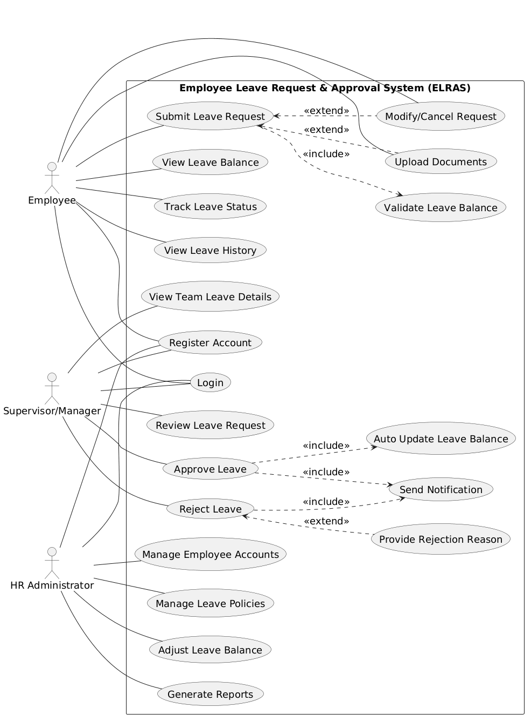
Figure.1 Use Case Diagram
Figure 1 shows use case diagram that illustrate how different users interact with the Employee Leave Request and Approval System. The diagram includes three main actors: Employee, Supervisor or Manager, and HR Administrator. Each actor has specific responsibilities in the system. The employee can register, log in, submit a leave request, check leave balance, track request status, and view leave history. While submitting a request, the employee may also upload documents or modify or cancel the request if needed. The system checks the leave balance before sending the request forward. The supervisor or manager receives the leave request and reviews it. Based on the decision, the manager can either approve or reject the request. If the request is approved, the system automatically updates the leave balance and sends a notification to the employee. If rejected, the manager provides a reason, and the system sends a rejection notification. The HR Administrator handles administrative tasks such as managing employee accounts, updating leave policies, adjusting leave balances, and generating reports. Overall, the diagram clearly shows the flow of actions and responsibilities among all users in the system.

4.2 Use Case Description
Use Case 1: Login
Use Case Name: Login | ID: UC-01 | Importance Level: High
Primary Actor: Employee, Manager, HR Administrator | Use Case Type: Essential
Stakeholders and Interests: | Users need secure access. System must verify identity.
Brief Description: | User logs into the system using credentials.
Trigger: | User enters login details
Type: | External
Relationships: | Association: Employee, Manager, HR Administrator  Include: None  Extend: None  Generalization: None
Normal Flow of Events: | 1. User enters username and password  2. System validates credentials  3. System grants access
SubFlows: | S-1: User retries if credentials are wrong
Alternate/Exceptional Flows: | System denies access if login fails
Related Functional Requirement | 9, 10

Use Case 2: Register Account
Use Case Name: Register Account | ID: UC-02 | Importance Level: Medium
Primary Actor: Employee, Manager, HR Administrator | Use Case Type: Supporting
Stakeholders and Interests: | Users need account creation. System stores user data.
Brief Description: | User creates a new account.
Trigger: | User selects register option
Type: | External
Relationships: | Association: Employee, Manager, HR Administrator  Include: None  Extend: None  Generalization: None
Normal Flow of Events: | 1. User enters details  2. System validates data  3. Account is created
SubFlows: | S-1: Missing or invalid data
Alternate/Exceptional Flows: | Registration fails if data is incorrect
Associated Functional Requirements: | 36, 32, 33

Use Case 3: Submit Leave Request
Use Case Name: Submit Leave Request | ID: UC-03 | Importance Level: High
Primary Actor: Employee | Use Case Type: Essential
Stakeholders and Interests: | Employee wants leave approval. System checks request.
Brief Description: | Employee submits leave details.
Trigger: | Employee selects apply leave
Type: | External
Relationships: | Association: Employee  Include: Validate Leave Balance  Extend: Upload Documents, Modify or Cancel Request  Generalization: None
Normal Flow of Events: | 1. Employee enters leave details  2. System checks balance  3. Request is submitted  4. Manager is notified
SubFlows: | S-1: Balance validation
Alternate/Exceptional Flows: | Request fails if balance is insufficient
Associated Functional Requirements: | 1, 22, 23, 30

Use Case 4: View Leave Balance
Use Case Name: View Leave Balance | ID: UC-04 | Importance Level: High
Primary Actor: Employee | Use Case Type: Essential
Stakeholders and Interests: | Employee wants correct balance.
Brief Description: | Employee views leave balance.
Trigger: | Employee selects view balance
Type: | External
Relationships: | Association: Employee  Include: None  Extend: None  Generalization: None
Normal Flow of Events: | 1. Employee requests balance  2. System displays balance
SubFlows: | S-1: Fetch balance data
Alternate/Exceptional Flows: | Error if data not available
Associated Functional Requirements: | 2, 16

Use Case 5: Track Leave Status
Use Case Name: Track Leave Status | ID: UC-05 | Importance Level: High
Primary Actor: Employee | Use Case Type: Essential
Stakeholders and Interests: | Employee wants status updates.
Brief Description: | Employee checks leave request status.
Trigger: | Employee selects track status
Type: | External
Relationships: | Association: Employee  Include: None  Extend: None  Generalization: None
Normal Flow of Events: | 1. Employee selects request  2. System shows status
SubFlows: | S-1: Retrieve status
Alternate/Exceptional Flows: | No records found
Associated Functional Requirements: | 3

Use Case 6: Modify or Cancel Request
Use Case Name: Modify or Cancel Request | ID: UC-06 | Importance Level: Medium
Primary Actor: Employee | Use Case Type: Supporting
Stakeholders and Interests: | Employee wants to update or cancel request.
Brief Description: | Employee modifies or cancels a pending request.
Trigger: | Employee selects modify or cancel option
Type: | External
Relationships: | Association: Employee  Include: None  Extend: Submit Leave Request  Generalization: None
Normal Flow of Events: | 1. Employee selects request  2. Employee updates or cancels  3. System saves changes
SubFlows: | S-1: Check request status
Alternate/Exceptional Flows: | Cannot modify after approval
Associated Functional Requirements: | 4, 5

Use Case 7: Upload Documents
Use Case Name: Upload Documents | ID: UC-07 | Importance Level: Medium
Primary Actor: Employee | Use Case Type: Supporting
Stakeholders and Interests: | Employee wants to attach proof. System stores documents.
Brief Description: | Employee uploads supporting documents for leave.
Trigger: | Employee selects upload option during request
Type: | External
Relationships: | Association: Employee  Include: None  Extend: Submit Leave Request  Generalization: None
Normal Flow of Events: | 1. Employee selects file  2. System uploads document  3. File is linked to request
SubFlows: | S-1: File validation
Alternate/Exceptional Flows: | Upload fails if file format is invalid
Associated Functional Requirements: | 8

Use Case 8: Review Leave Request
Use Case Name: Review Leave Request | ID: UC-08 | Importance Level: High
Primary Actor: Supervisor/Manager | Use Case Type: Essential
Stakeholders and Interests: | Manager wants to review request details.
Brief Description: | Manager reviews employee leave request.
Trigger: | Manager receives leave request notification
Type: | External
Relationships: | Association: Supervisor/Manager  Include: None  Extend: None  Generalization: None
Normal Flow of Events: | 1. Manager opens request  2. Manager checks details  3. Manager prepares decision
SubFlows: | S-1: View employee details
Alternate/Exceptional Flows: | Request not found
Associated Functional Requirements: | 11, 12, 16

Use Case 9: Approve Leave
Use Case Name: Approve Leave | ID: UC-09 | Importance Level: High
Primary Actor: Supervisor/Manager | Use Case Type: Essential
Stakeholders and Interests: | Employee wants approval. System updates records.
Brief Description: | Manager approves leave request.
Trigger: | Manager selects approve option
Type: | External
Relationships: | Association: Supervisor/Manager  Include: Auto Update Leave Balance, Send Notification  Extend: None  Generalization: None
Normal Flow of Events: | 1. Manager approves request  2. System updates balance  3. Notification is sent
SubFlows: | S-1: Balance update
Alternate/Exceptional Flows: | Approval fails if system error occurs
Associated Functional Requirements: | 13, 21, 25

Use Case 10: Reject Leave
Use Case Name: Reject Leave | ID: UC-10 | Importance Level: High
Primary Actor: Supervisor/Manager | Use Case Type: Essential
Stakeholders and Interests: | Employee wants clear decision.
Brief Description: | Manager rejects leave request.
Trigger: | Manager selects reject option
Type: | External
Relationships: | Association: Supervisor/Manager  Include: Send Notification  Extend: Provide Rejection Reason  Generalization: None
Normal Flow of Events: | 1. Manager rejects request  2. Manager provides reason  3. Notification is sent
SubFlows: | S-1: Enter rejection reason
Alternate/Exceptional Flows: | Rejection fails if reason not provided
Associated Functional Requirements: | 13, 25

Use Case 11: Provide Rejection Reason
Use Case Name: Provide Rejection Reason | ID: UC-11 | Importance Level: Medium
Primary Actor: Supervisor/Manager | Use Case Type: Supporting
Stakeholders and Interests: | Employee wants clear explanation.
Brief Description: | Manager enters reason for rejection.
Trigger: | Triggered during leave rejection
Type: | Internal
Relationships: | Association: Supervisor/Manager  Include: None  Extend: Reject Leave  Generalization: None
Normal Flow of Events: | 1. Manager enters reason  2. System saves reason
SubFlows: | S-1: Input validation
Alternate/Exceptional Flows: | Error if reason is empty
Associated Functional Requirements: | 14

Use Case 12: View Team Leave Details
Use Case Name: View Team Leave Details | ID: UC-12 | Importance Level: Medium
Primary Actor: Supervisor/Manager | Use Case Type: Supporting
Stakeholders and Interests: | Manager wants team leave visibility.
Brief Description: | Manager views leave details of team members.
Trigger: | Manager selects team leave option
Type: | External
Relationships: | Association: Supervisor/Manager  Include: None  Extend: None  Generalization: None
Normal Flow of Events: | 1. Manager selects team view  2. System displays leave details
SubFlows: | S-1: Fetch team data
Alternate/Exceptional Flows: | No data available
Associated Functional Requirements: | 15, 29

Use Case 13: Manage Leave Policies
Use Case Name: Manage Leave Policies | ID: UC-13 | Importance Level: High
Primary Actor: HR Administrator | Use Case Type: Essential
Stakeholders and Interests: | HR wants control over leave rules.
Brief Description: | HR defines or updates leave policies.
Trigger: | HR selects policy management option
Type: | External
Relationships: | Association: HR Administrator  Include: None  Extend: None  Generalization: None
Normal Flow of Events: | 1. HR enters policy details  2. System saves policy
SubFlows: | S-1: Validate policy data
Alternate/Exceptional Flows: | Update fails if data is invalid
Associated Functional Requirements: | 17

Use Case 14: Adjust Leave Balance
Use Case Name: Adjust Leave Balance | ID: UC-14 | Importance Level: High
Primary Actor: HR Administrator | Use Case Type: Essential
Stakeholders and Interests: | HR needs to correct leave balance.
Brief Description: | HR updates employee leave balance.
Trigger: | HR selects adjust balance option
Type: | External
Relationships: | Association: HR Administrator  Include: None  Extend: None  Generalization: None
Normal Flow of Events: | 1. HR selects employee  2. HR updates balance  3. System saves changes
SubFlows: | S-1: Validate input
Alternate/Exceptional Flows: | Update fails if data is incorrect
Associated Functional Requirements: | 18

Use Case 15: Generate Reports
Use Case Name: Generate Reports | ID: UC-15 | Importance Level: Medium
Primary Actor: HR Administrator | Use Case Type: Supporting
Stakeholders and Interests: | HR needs reports for analysis.
Brief Description: | HR generates leave usage reports.
Trigger: | HR selects generate report option
Type: | External
Relationships: | Association: HR Administrator  Include: None  Extend: None  Generalization: None
Normal Flow of Events: | 1. HR selects report type  2. System generates report  3. Report is displayed or downloaded
SubFlows: | S-1: Data processing
Alternate/Exceptional Flows: | Report generation fails if data missing
Associated Functional Requirements: | 19, 27

Use Case 16: Manage Employee Accounts
Use Case Name: Manage Employee Accounts | ID: UC-16 | Importance Level: High
Primary Actor: HR Administrator | Use Case Type: Essential
Stakeholders and Interests: | HR manages user access.
Brief Description: | HR enables or disables employee accounts.
Trigger: | HR selects account management option
Type: | External
Relationships: | Association: HR Administrator  Include: None  Extend: None  Generalization: None
Normal Flow of Events: | 1. HR selects employee  2. HR updates account status  3. System saves changes
SubFlows: | S-1: Account validation
Alternate/Exceptional Flows: | Action fails if system error occurs
Associated Functional Requirements: | 32

Use Case 17: Validate Leave Balance
Use Case Name: Validate Leave Balance | ID: UC-17 | Importance Level: High
Primary Actor: System | Use Case Type: Internal
Stakeholders and Interests: | System ensures valid leave request. Employee avoids errors.
Brief Description: | System checks if enough leave balance exists.
Trigger: | Triggered during leave request submission
Type: | Internal
Relationships: | Association: System  Include: None  Extend: None  Generalization: None
Normal Flow of Events: | 1. System checks leave balance  2. System validates request
SubFlows: | S-1: Retrieve balance data
Alternate/Exceptional Flows: | Request blocked if balance is insufficient
Associated Functional Requirements: | 22

Use Case 18: Auto Update Leave Balance
Use Case Name: Auto Update Leave Balance | ID: UC-18 | Importance Level: High
Primary Actor: System | Use Case Type: Internal
Stakeholders and Interests: | System maintains correct records.
Brief Description: | System updates leave balance after approval.
Trigger: | Triggered after leave approval
Type: | Internal
Relationships: | Association: System  Include: None  Extend: None  Generalization: None
Normal Flow of Events: | 1. System deducts approved leave  2. System updates balance
SubFlows: | S-1: Data update
Alternate/Exceptional Flows: | Update fails if system error occurs
Associated Functional Requirements: | 21

Use Case 19: Send Notification
Use Case Name: Send Notification | ID: UC-19 | Importance Level: High
Primary Actor: System | Use Case Type: Internal
Stakeholders and Interests: | Users want timely updates.
Brief Description: | System sends notification for leave updates.
Trigger: | Triggered during approval or rejection
Type: | Internal
Relationships: | Association: System  Include: None  Extend: None  Generalization: None
Normal Flow of Events: | 1. System generates message  2. Notification is sent to user
SubFlows: | S-1: Message creation
Alternate/Exceptional Flows: | Notification fails if network issue occurs
Associated Functional Requirements: | 6, 11, 25

Use Case 20: Provide Rejection Reason
Use Case Name: Provide Rejection Reason | ID: UC-20 | Importance Level: Medium
Primary Actor: Supervisor/Manager | Use Case Type: Supporting
Stakeholders and Interests: | Employee needs clear reason.
Brief Description: | Manager enters reason for rejection.
Trigger: | Triggered during leave rejection
Type: | Internal
Relationships: | Association: Supervisor/Manager  Include: None  Extend: Reject Leave  Generalization: None
Normal Flow of Events: | 1. Manager enters reason  2. System saves reason
SubFlows: | S-1: Validate input
Alternate/Exceptional Flows: | Error if reason is empty
Associated Functional Requirements: | 14

4.3 Activity Diagram
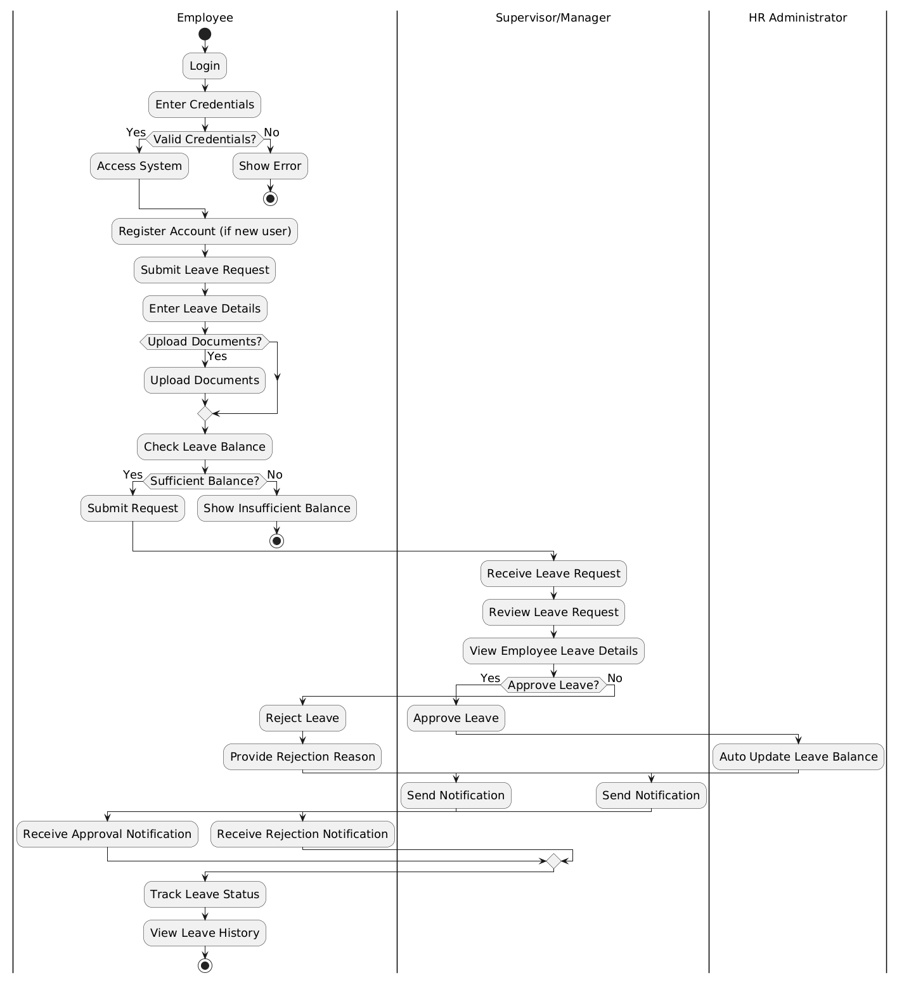
Figure.2 Activity Diagram
Figure 2. activity diagram shows the overall process of how the Employee Leave Request and Approval System works. The flow starts when the employee logs into the system and enters correct login details. Once access is granted, the employee fills in the leave request form and can also upload documents if needed. The system then checks whether the employee has enough leave balance. If the balance is sufficient, the request is sent to the supervisor or manager for review. The manager checks the request and decides to approve or reject it. If the request is approved, the HR Administrator updates the leave balance and the system sends a notification to the employee. If the request is rejected, a reason is provided and the employee is informed. At the end, the employee can view the leave status and history. The swimlanes clearly show the roles of each actor in the process.

4.4 Sequence Diagram
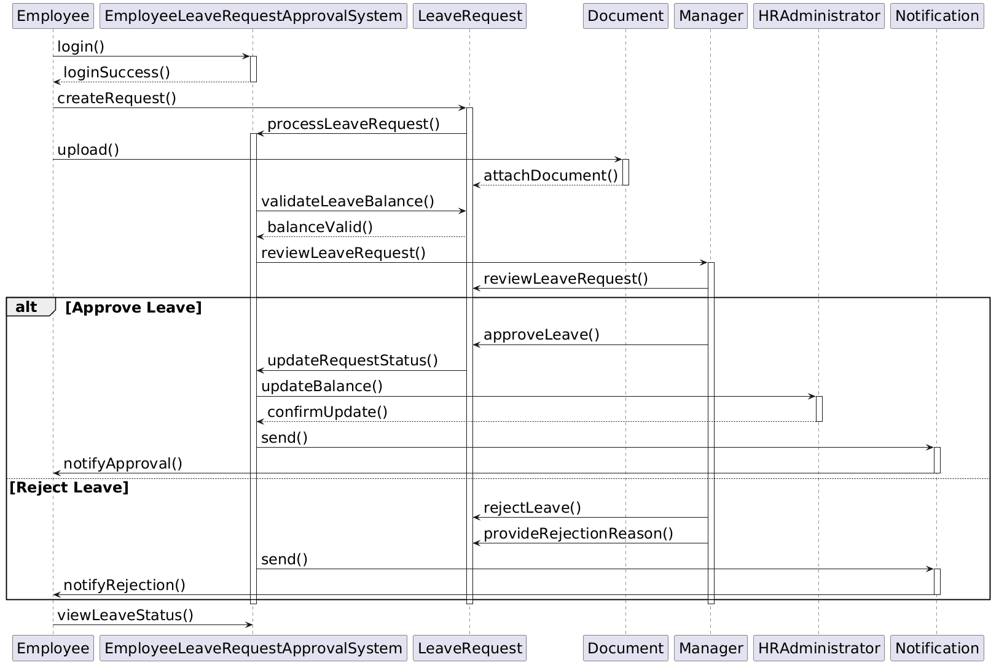
Figure.3 Sequence Diagram
Figure 3 shows sequence diagram how different system components interact step by step when an employee submits a leave request. The process begins with the employee logging into the system. Once the login is successful, the employee creates a leave request. The system processes this request and allows the employee to upload supporting documents, which are attached to the leave request. Next, the system checks whether the employee has enough leave balance. If the balance is valid, the request is forwarded to the manager for review. The manager examines the request and makes a decision. If the leave is approved, the system updates the request status and sends it to the HR Administrator to update the leave balance. After that, a notification is sent to the employee confirming approval. If the manager rejects the request, a rejection reason is provided. The system then sends a rejection notification to the employee. Finally, the employee can view the leave status in the system. Overall, the diagram clearly shows the message flow between objects and how the system handles both approval and rejection scenarios.

4.5 Class Diagram
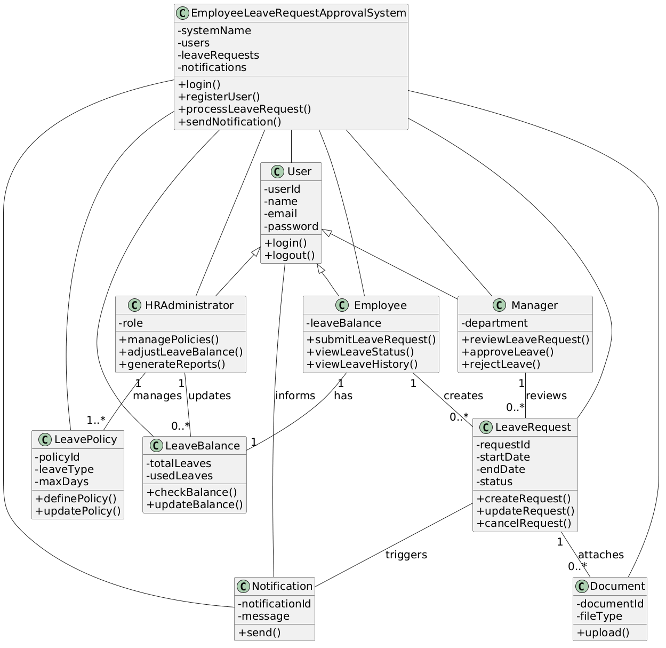
Figure.4 Class Diagram
Figure 4 shows Class diagram which explains the structure of the Employee Leave Request and Approval System by presenting the main classes and how they are connected. At the top, the system class, EmployeeLeaveRequestApprovalSystem, controls overall operations such as login, user registration, processing leave requests, and sending notifications. It connects with all other classes, showing that it manages the complete system. The User class acts as a base class and contains common details like user ID, name, email, and password. From this class, three specialized classes are derived: Employee, Manager, and HRAdministrator. This inheritance helps reduce repetition and keeps the design organized. The Employee class is responsible for submitting leave requests and checking leave status. The Manager class handles reviewing, approving, or rejecting requests. The HRAdministrator manages policies, updates leave balances, and generates reports. The LeaveRequest class represents the actual leave details such as dates and status. It is created by the employee and reviewed by the manager. The LeaveBalance class keeps track of total and used leaves, while the LeavePolicy class defines rules like leave limits. The Document class allows attaching supporting files, and the Notification class sends updates to users.

4.6 Object Diagram
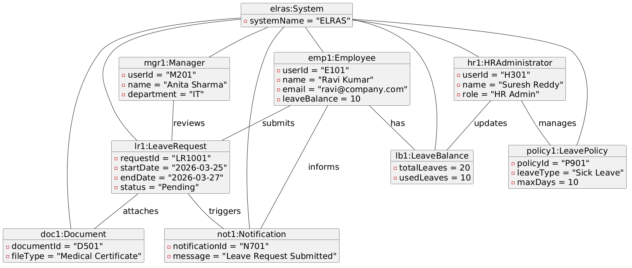
Figure.5 Object Diagram
Figure 5 shows object diagram which illustrates the real working example of the Employee Leave Request and Approval System by representing actual objects with sample data. It explains how different objects are connected when an employee submits a leave request. At the top, the system object “elras:System” controls and connects all other objects in the process. The employee object (emp1) includes details such as user ID, name, email, and leave balance. This employee submits a leave request shown by the object lr1, which contains information like request ID, start date, end date, and status. The manager object (mgr1) is linked to the leave request and is responsible for reviewing it. The HR administrator object (hr1) handles administrative tasks such as updating leave balance and managing leave policies. The leave balance object (lb1) shows how many leaves are available and used. The leave policy object defines rules like leave type and maximum allowed days. The document object (doc1) represents a file attached to the leave request, and the notification object (not1) shows a message sent to the employee. Overall, the diagram clearly explains how objects interact during the leave request process.

5. Use-Case to Class Mapping Table
Use Case ID | Use Case Name | Related Classes
UC-01 | Login | User, EmployeeLeaveRequestApprovalSystem
UC-02 | Register Account | User, EmployeeLeaveRequestApprovalSystem
UC-03 | Submit Leave Request | Employee, LeaveRequest, EmployeeLeaveRequestApprovalSystem
UC-04 | View Leave Balance | Employee, LeaveBalance
UC-05 | Track Leave Status | Employee, LeaveRequest
UC-06 | Modify/Cancel Request | Employee, LeaveRequest
UC-07 | Upload Documents | Employee, Document, LeaveRequest
UC-08 | Review Leave Request | Manager, LeaveRequest
UC-09 | Approve Leave | Manager, LeaveRequest, LeaveBalance, Notification
UC-10 | Reject Leave | Manager, LeaveRequest, Notification
UC-11 | Provide Rejection Reason | Manager, LeaveRequest
UC-12 | View Team Leave Details | Manager, Employee, LeaveRequest
UC-13 | Manage Leave Policies | HRAdministrator, LeavePolicy
UC-14 | Adjust Leave Balance | HRAdministrator, LeaveBalance
UC-15 | Generate Reports | HRAdministrator, LeaveRequest, LeavePolicy
UC-16 | Manage Employee Accounts | HRAdministrator, User
UC-17 | Validate Leave Balance | LeaveRequest, LeaveBalance
UC-18 | Auto Update Leave Balance | LeaveBalance, EmployeeLeaveRequestApprovalSystem
UC-19 | Send Notification | Notification, EmployeeLeaveRequestApprovalSystem

6. Implementation Plan
I will build this system using Python as the main backend because it is easy to work with and supports web application development well. I will use Visual Studio Code for coding since it is simple to use and helps in writing and managing code efficiently. For the frontend part, I will design the interface using HTML and CSS to make it clear and user-friendly. For handling the application logic, I plan to use a Python framework such as Flask, which is suitable for developing web-based applications. To store data like employee details, leave requests, and records, I will use a database such as MySQL or SQLite based on the project needs. The database will be organized properly to keep data safe and easy to access. My goal is to create a system that is simple, efficient, and easy for users to understand, while handling leave requests in a smooth and reliable way.

7. References
Munawir, A., Pratama, G. U., Auliana, S., Rohman, A., & Rizki, M. (2024). Enhancing leave management through an online employee leave application system. ARRUS Journal of Engineering and Technology, 4(1), 26–36. https://doi.org/10.35877/jetech2711

